## Merging the data from two datasets (files) using VSAM read on key.

It is quite often that a programmers will be asked to match and merge data from two files into one file. In this situation, the second file is a VSAM KSDS (key sequenced) file.

## INPUT 1: DD DSN=SHARE.GET433.STUDENT.DATA(CBL9),DISP=SHR

* Name 1 thru 20 PIC X(20)
* Address 21 thru 40 PIC X(20)
* Social Security No 41 thru 49 PIC 9(9)
* Sequential zOS file, 80 bytes per record
* DISP=SHR - means all can use as for input

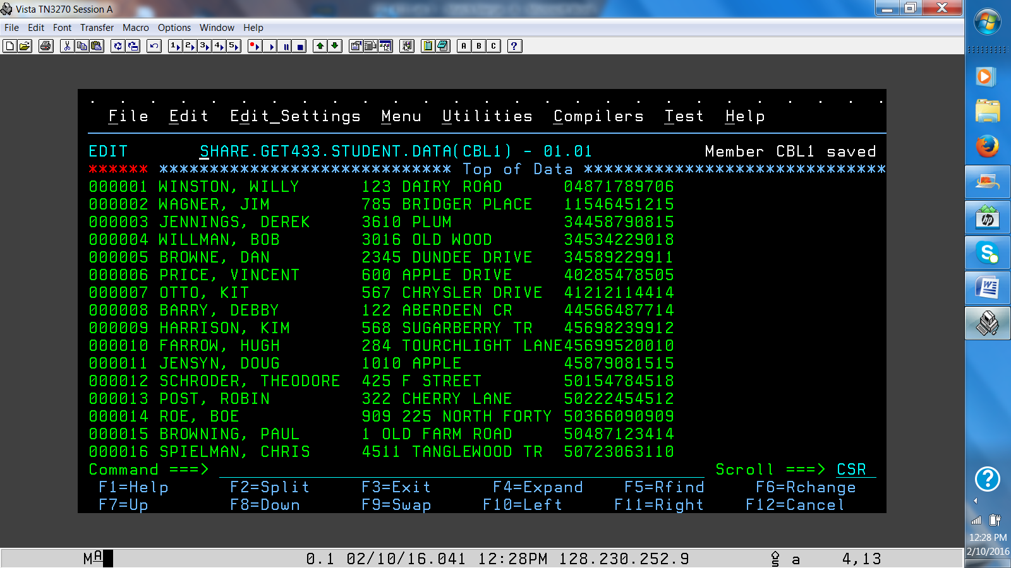

## INPUT 2: DD DSN= SHARE.GET433.TEST.VSAM,DISP=SHR

* Social Security No 41thru 49 PIC 9(9)
* Credits 50 thru 51 PIC XX
* Sequential VSAM file, 80 bytes per record
* DISP=SHR - means all can use as for input

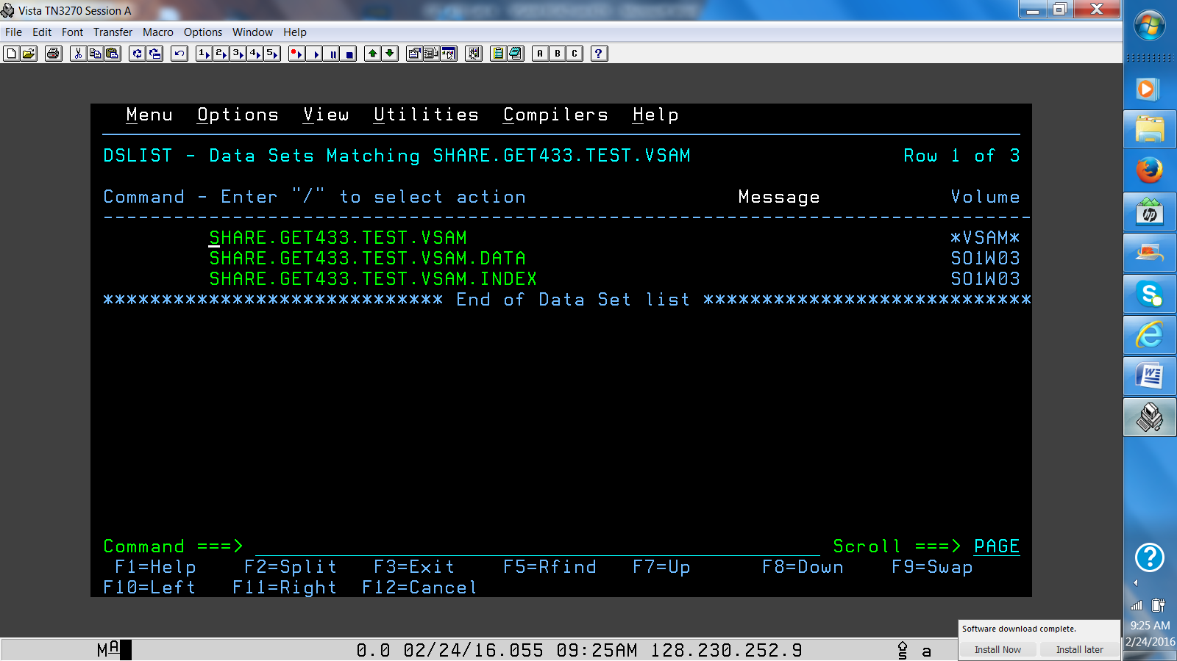

**PROCESS:**

* **Create a COBOL base program in your source library**
* **For the VSAM file use the following copies - VSAMFD, VSAMRC, VSAMSEL in the appropriate places of the COBOL program.**
* **Define the INPUTs (SELECT, FD, OPEN, READ, CLOSE)**
* **Define the OUTPUT (SELECT, FD, OPEN, WRITE, CLOSE)**
* **Write the necessary PROCEDURE DIVISION statements to read thru all of the input file. For each record populate the output record and write the record to the output print file.**
* **Use a read on key of the VSAM file to get the record with the year of graduation. Populate the output year of graduation from the VSAM file input.**
* **If the VSAM record is not found (VSAMRC not = '00'- move '????' to the year of graduation for the O/P record.**
* **When found, populate the output record and write the appropriate O/P record.**
* **Take a screen shot of your output file and place it in Blackboard.**

**OUTPUT:**

**Record layout:**

**Name PIC X(20).**

**Address PIC X(20).**

**SSN PIC 9(9).**

**Credits PIC XX.**

**Filler PIC X(29)**

**//OFILE DD DSN=SUS00nn.GET239.LAB3.OUTPUT,**

**// DISP=(NEW,CATLG,DELETE),**

**// DCB=(BLKSIZE=0,LRECL=80,RECFM=FB),**

**// SPACE=(CYL,(1,1),RLSE),**

**// UNIT=SYSDA**

**Question:**

**1. Name and describe a business case for using a match merge program.**

**2. Can the algorithm for this program be used for other than COBOL programs?**